**Future Housing Need in Coventry  
Monitor and Decide**

**The Context:**

* Past forecasts of population growth in Coventry, the SNPP and MYE, have proved badly wrong when the 2011 and 2021 censuses finally came in.
* Recently, ICENI projects have produced a [**new forecast**](https://www.coventry.gov.uk/downloads/download/7374/coventry-and-warwickshire-housing-and-economic-development-needs-assessment-hedna) but how reliable is this new projection?
* Unfortunately, the information to answer this question is unavailable. All requests, to see the components of change spreadsheet underlying the ICENI report, have been refused. We need to see their trajectory of births, deaths, internal migration, and international migration.
* Future growth all depends on migration in and out of Coventry. If natural increase, births and deaths was the only source of change, within this decade, the population would soon be shrinking, in both Coventry and the larger Housing Market Area [HMA] – see the appendix Fig 1 & 2. It means that we need a much better understanding of migration -especially of students - than we currently have.
* Beyond this. there is a more general and fundamental issue, “Can the the SNPP projection model, with a few tweaks from ICENI, ever produce a reliable forecast?”

**Where do we go?**

* It appears that ICENI have adjusted the ONS model, using a single constant correction factor. i.e. deducting 4000 from migration each year. Why should we believe that the correction factor will remain constant over time, especially when ONS forecasts of international migration and birth rates have been poor, and the skimpy migration data which we currently rely on, have been exceedingly inadequate.
* There is an alternative approach: **Monitor and Decide -** ie to use administrative data to see real time housing and infrastructure needs, instead of relying on ‘projections’ which in the past have quickly drifted far from reality. Long before the 2021 census came out, administrative data alerted us that SNPP2014 could not possibly be correct – the numbers were absurd for Coventry.
* We consider that ‘Monitor and Decide’ is a better approach. While no single administrative dataset can be a proxy for a census, nevertheless, it makes great good sense to combine datasets to produce Evidence Based Mid Year Estimates {EBMYE] with resultant housing and infrastructure need.

Compare the accuracy of the MYE, SNPP, EBMYE, with the reality of the Census.

|  |  |
| --- | --- |
|  | **Predicted Coventry 2021 Population** |
| MYE2020+9 month adjustment | 385,287 |
| SNPP2014 | 374,500 |
| EBMYE – from housing completions [completions*2.47persons/home] | 348,275 |
| Census 2021 | 345,200 |

**If the SNPP projections and ONS were a football team, then surely they would have been relegated and the manager fired a long time ago.** Why continue with that approach, slightly modified, when it has failed time and again?

* If one had an evidence based population estimate each year, or each 5 years -then the housing trajectory, and allocations could be adjusted up or down in the coming 5 year period, in accord with real and reliable trends. So every single year, from 2011-2021, we had available to us, a simple evidence based population forecast, that turned out to be much more reliable than the SNPP. With more refinement, it could be even better.
* As suggested by the CPRE letter of complaint to UKSA of Nov 2020, admin data which could be usefully included in a local model of population change, would include, births, deaths, NINO registrations, HESA destinations data, A&E attendance, electoral roll data, car registrations, electricity and gas consumption, job creation, the patient register, school admissions, domestic waste collection tonnage,
* ONS themselves are aiming towards replacing the census with an Administrative Based Population Estimate [ABPE]. In principle, a Coventry, or Coventry and Warwickshire based EBMYE, would align with gathering models and practice at ONS. Unfortunately, the ONS models [ABPE2 and ABPE3] did not successfully predict the outcome of the census for Coventry, but they were better than the MYE and SNPP . Our housing based census, as crude as it is, did better than the either ABPE2 or 3

|  |  |
| --- | --- |
| Estimate and year | 2020 Coventry population estimate |
| ABPE3 to 2020 | 363,302 |
| ABPE2 in 2020 | 378,352 |
| MYE2020 | 379387 |
| Dwellings based estimate2020 EBMYE | 346,820 |
| Census 2021 | 345,200 |

* Given the very large numbers of students, - circa 60,000 at the 2 universities , see graph in the appendix - and their transience, it is essential to account for them separately. From HESA data, we know that very few of them stay in Coventry after graduation[1]. It appears that ONS counted students in but did not count them out, and that they grossly over counted female students who might become mothers.

**The big picture in Coventry**

1. **Natural Increase:** birth rates are plummeting and death rates, are nearly flat. [see Fig 3 & 4] Within the span of the next local plan, it is likely that deaths will outnumber births and population from natural causes will shrink. Natural increase was +2171 in 2011 but just +885 in 2021. On present trends, it could reach zero in 2029 and be minus 678 by 2041. In the HMA natural increase is going down even faster – likely to reach zero by 2027. See the appendix.
2. **Migration: We need more information**. We simply do not know how Iceni have modelled internal and international migration. See above.   
     
   At the heart of the HEDNA, is a giant lump of statistical polyfilla. To fill up the yawning gap between the ONS forecasts in SNPP2014, and the actual census outcome, the HEDNA applies a crude fix, subtracting a fixed figure of 4000 persons from projected migration each year to make the numbers come out right. We do not learn, how or why this error arose, nor whether or not it is likely to get better, or worse. It is not good enough just to apply an unchanging correction factor, which in hindsight worked for the last decade, when we have no idea if it is likely to be true for the coming decades. Things change, and fast.   
     
   Internal Migration .We only get reasonably solid data once every ten years, at the census, on internal migration [about movers to and from Coventry, from other locations in the UK]. From this data, internal migration appears to be gently increasing, going from minus 885 in 2011 to positive 126 in 2021 – a shift of about a thousand/yr over 10 years.. We do not know how this is likely change in the future. An obvious question, is whether or not this was related to job creation, or some other factor – say refugees?, marriage? Caring needs? Unaffordable housing in the South East? It should be possible to find out and apply that understanding to the future.

|  |  |  |
| --- | --- | --- |
|  | Net Internal Migration to & from **Coventry** in the year preceding the Census | Net Internal Migration to & from the **Cov and Warks Housing Market Area** |
| At the 2001 Census | -1068 | Not available |
| At the 2011 Census | -885 | 293 |
| At the 2021 Census | ‘+126’ | 6296 |

1. For international migration, the situation is worse. At the census, we only learn about people who have arrived in the UK from overseas, but there is no data at all on international emigrants , for the obvious reason that people who leave the UKdo not fill in UK census forms.   
     
   Given that thousands of international students come to Coventry every year, - around 16,500 first year foreign students in 2021 - we need to understand much better how many of them settle in Coventry and how many leave after graduation. In cooperation with the universities, it should be possible to work this out – the data resources, the HESA destinations survey, Home office visa records, and university alumni records, already exist.
2. A sketch of students in 2021-22  
     
   HESA Table 1 2021/22 data.

|  |  |  |  |
| --- | --- | --- | --- |
| University | First Year | Other years [2yrs & up] | Total |
| **Coventry Uni** |  |  |  |
| Foreign students – | 9845 | 5720 | 15565 |
| Total, all students | 18010 | 20180 | 38190* |
| **U of Warwick** |  |  |  |
| Foreign students | 6600 | 4465 | 11065 |
| Total all students | 13450 | 15280 | 28730 |

*approximately 6000 Coventry Univ students are at external campuses; in Poland, London, and Scarborough. It is likely that there are circa 32,000 students actually at the Coventry City campus of Coventry Univ. data from FOI request.

1. Contrary to public perceptions, overall student numbers have not markedly gone up in the last decade 2011-2021.
2. It remains a problem, how to measure other international migration - for non students such as workers, family members, and refugees. However, if the new Data Protection Data and Information Bill currently before Parliament becomes law, it will be very much easier for government departments to share data – in principle tax, benefits, and visa data, could greatly assist in understanding international migration into and out of Coventry, including non students [ migrant workers, family movers, refugees etc]
3. Any conclusions drawn from sketchy information and crude correction factors- must be treated with considerable caution.
4. A sensible way to proceed would be to make planning permissions in the 2nd, 3rd, and 4th, quarter [5 year period] of the plan conditional on market signals. The market can tells us if houses are in short supply or not, even if we don’t have good information about migration or population. At present, house prices in Coventry are below the national average, indicating that current delivery, [13,000 gross over 10 years, Net of student accommodation 1017/yr] ,] has been perfectly adequate. ONS figures show that average house price in Coventry in 2021 was £227,539 while the England average price was £355,000. See the appendix fig 7 & 8
5. Need for student housing and family housing has to be assessed separately. Over the years 2011-2020, approximately 11,000 bed places[2] were provided in purpose built student accommodation. How these have been counted in housing completions is unclear. At times the council has said that 2.5 beds – in a flat with facilities and a door - equates to one dwelling completion while other guidance says that student accommodation will be counted as 6-8 beds as one dwelling. Using the Council figure [2.5 beds/dwelling counted], 11,000 bed places translates to 11,000/2.5 = 4,400 completions. Assuming that the students previously occupied private rented homes, at 7 students/HMO[3], this would free up 11,000/7 =1571homes. Net result? See below  
     
    **net addition to residential stock over 10 years**  
   Net homes for the family market = 13,000gross completions -4,400 built for students + 1571freed up HMOs = 10171   
   On this basis, the housing need, would be for 1,017 homes/year.   
     
   [=Gross completions – purpose built student accommodation @2.5beds/completion + homes freed up as students move out of them]

**APPENDIX**

**Natural Increase, Actual v Forecast**

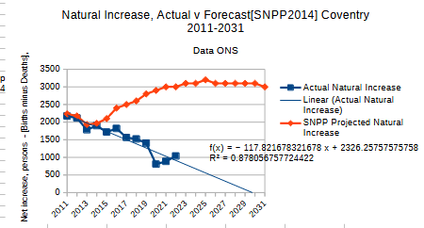Figure 1

Figure 2

**Cov & Warks HMA Births and Deaths. Actual v Forecast**

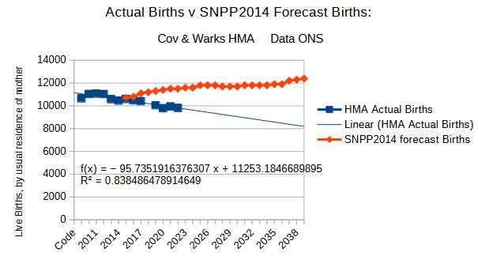Figure 3

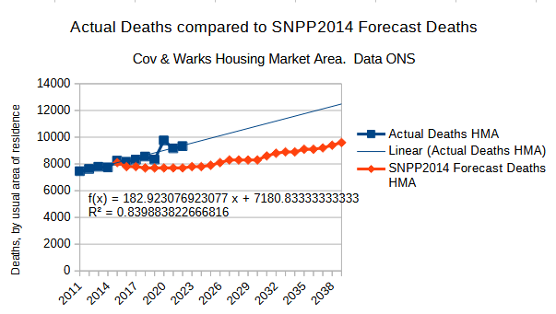Figure 4

**Coventry Actual v Forecast Births and Deaths**

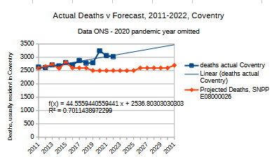Figure 5

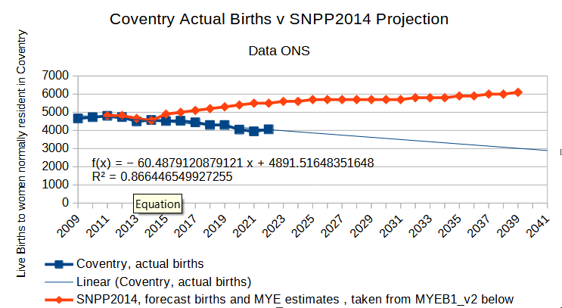Figure 6

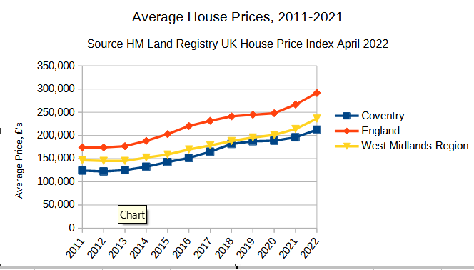Figure 7

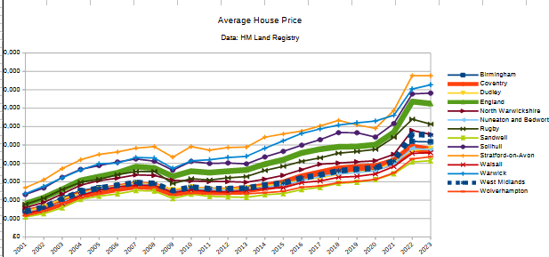Figure 8

Figure 9

1. 6-15% from HESA Destinations of Leavers of Higher Education annual survey. The DLHE
2. Data from FOI requests, planning applications, and the Coventry Evening Telegraph. See <https://www.coventrytelegraph.net/news/coventry-news/university-signals-desire-more-student-17788833> Tom Davis, the reporter, emailed that the numbers came from Coventry University Head of Accommodation in a Council meeting
3. Figures on students / HMO supplied by Westwood Heath Residents Association.