It’s Official - Statistics Can Destroy the Environment.

Merle Gering of the Campaign for Protection of Rural England reviews the reconciliation of mid-year population estimates with Census 2021 at local authority level.

On 2 March 2023, ONS released its reconciliation of the 2021 Census and the Mid-Year Estimates (MYE), rolled forward from 2011. The results confirmed that for more than 30 local authorities, the rolled forward estimates had proved to be substantially too large or too small: out by more than 5%. Notably in places like Cambridge, Coventry, Sheffield and Westminster.

But that way of stating the errors: as a percent of the total population, conceals the serious nature of the problem. It is not the total of the population which matters. It is the change since the last census, the overstatement or understatement of the increase or decrease which matters . Because it is that addition [or loss] of peoplethat determines the need for more homes, schools, clinics, hospitals, roads and other public services. If you look at the estimated increase as a proportion of the actual increase, then the rolled forward estimate of growth for Coventry was 100% too large, leading to large amounts of the green belt being bulldozed forever on the basis of inaccurate population forecasts. Those numbers spelled the death-knell for ancient hedges, fields, and wildlife. Similar calamities occurred in Canterbury, Sheffield, and Guildford.

For Cambridge, the opposite was true. The Rolled Forward Mid-Year Estimates in 2021, understated the actual population growth by 1000%. Only 10% of the actual population increase was predicted. On the back of the MYE rolled forward from 2011, Cambridge would only have needed an extra 913 homes between 2011 and 2021. In fact, given the size of actual population increase, it needed 9480 new homes, to provide for all the newcomers!

In this new publication ONS blandly ignores the consequences of their blunders with the mid-year estimates. They don’t apologise. They don’t explain. Worst of all, they do not even consider whether or not they could have done better, or if it is just bad luck, that the MYE are so poor in many places. They do not reflect on whether anything can be done to improve the quality of the MYE.

Three questions arise:

- Was this a new problem?
- Could it have been foreseen?
- Could ONS have done better?

It is not a new problem. ONS had ten years, at least, to deal with this issue. They had exactly the same problem in 2011. The MYE did not match up with the outcomes of the 2011 Census, in a good number of places. In fact the same places crop up in both 2011 and 2021 eg Coventry, Cambridge, City of London, Hackney, Islington, Westminster, Leicester, etc Ten years of tinkering was not enough to find a remedy.

There are other ways of measuring the population between the census years. ONS themselves have been trying to use administrative data, in various pilots, since at least 2011, and maybe before. At least in Northern Ireland, they claimed that their modelling produced a result within 1.5% of the 2011 census outcomes.

Here is a brief look, at whether or not housing completions, could have foretold where the population estimates were going wrong.

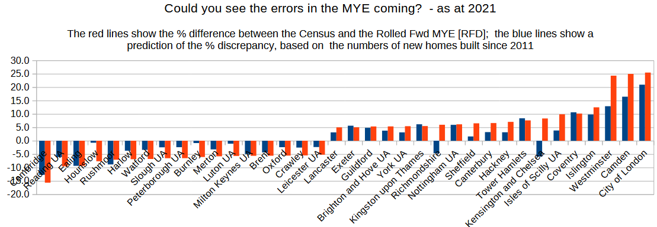

The Red lines in the chart above show the percent gap between the MYE rolled forward from 2011, and the actual 2021 Census – as identified in the ONS reconciliation. The blue lines compare the gap between the MYE rolled forward from 2011, and an estimate of population derived from numbers of new homes built in the ten years 2011-21.

The number of homes built appears to be a reasonable proxy for the census – it predicts where there are large differences with the rolled forward MYE - both positive and negative - and gets the pattern right, identifying the localities where the MYE are much too large, and where they are much too small. It isn’t perfect, but it does appear to give the right picture.

Critically, such checks on the MYE can be carried out between the census years.

Below, is the comparison in 2016 – these are all the same towns that ONS identified in their latest reconciliation as posing problems, where the rolled forward MYE from 2011 are more than 5% adrift of the census outcome in 2021. You can already see the towns, on the right side of the graph, where the MYE are too large. In plain English, not enough homes have been built to accommodate all the people predicted by the MYE.

Anyone could have carried out this reality check on the mid-year estimates, by counting the number of homes completed – the information is readily available at local authority level, from the Department of Levelling Up, Communities, and Housing [Live Table 253]. You can see below such a check done in 2016.

The red lines show the outcome in 2021 i.e. the difference, as percentage, between the census and the MYE rolled forward from 2011 [Census – MYE rolled forward from 2011]]/[MYE2021rolled forward from 2011. The blue lines show the gap, as a percent of the MYE, between the MYE and a dwellings-based estimate of the population. [DBE - MYE]/MYE2016
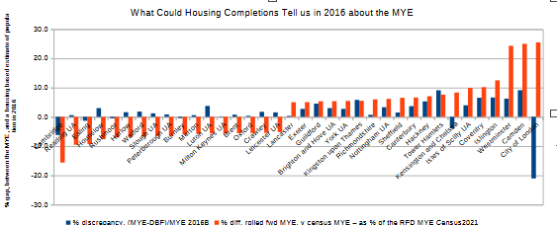

Here is the same analysis in 2019.

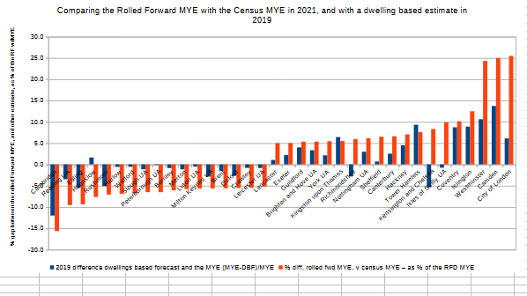

ONS could have done this analysis. It does not take Einstein to reason that people need a place to live, and that the number of new homes built will give an indication of population growth. My analysis was done very crudely. I did not take account of communal establishments, or empty homes held as investments, or areas like central London where there may well be an excess of overt and covert homes in multiple occupation. There are many other indicators of population besides house building, which could have been factored in to give an estimate of population. Rubbish collection, benefits, council tax records, electricity and gas usage, school admissions, hospital A&E attendance – all are reasonable proxies.

You have to ask: what is ONS’s agenda, when it comes to admitting errors and mistakes? We know that in Nov 2020 Sir David Norgrove, Chair of the UK Statistics Authority looked at our alternative population estimates for Coventry and, when we complained, agreed that the SNPP (SubNational Population Projections) and MYE were badly inaccurate for some towns

“It looks on the face of it as though they have a strong case and it is the kind of thing where ONS should be engaging, especially given the weight that MHCLG6 are putting on these numbers’’ [email obtained through FOI]. ‘’And the National Statistician, Sir Ian Diamond, made a similar remark’’ [also obtained through FOI]

Yet ONS did nothing to warn the public, or local authorities, even though they knew MHCLG (Ministry of Housing, Communities and Local Government) were using inaccurate numbers and in some cases it was wrecking the countryside – providing homes for people who did not exist.

In closing, I can only agree with Lord Andrew Tyrie, who wrote in 2016, when Chair of the Commons Treasury Select Committee:

“It’s clear from Sir Charles’s [Bean] interim report that the UK has fallen behind other countries, and that some of our statistics are scarcely fit for purpose...

The ONS has fallen a long way short, lacking intellectual curiosity, prone to silly mistakes and unresponsive to the needs of consumers of its statistics.”

25 September 2012 Examining the difference between the rolled-forward mid-2011 population estimates and the 2011 Census-based MYEs at local authority level.
Statement at BSPS conference 2018
Estimated by multiplying the number of new dwellings added since 2011 by the average household size for each locality, as derived from the 2011 census, to get an estimate of the increase in population. It is a crude procedure, but it seems to work reasonably well.
The letter of complaint can be viewed here: https://docs.google.com/document/d/1tzyneQGoczSKbDF3MUP_iUnNe7zJQLkU/edit?usp=share_link&ouid=106113341902589611621&rtpof=true&sd=true 6 MHCLG: Ministry of Housing, Communities and Local Government

